Limb Amputation and Prosthetic Care Manual
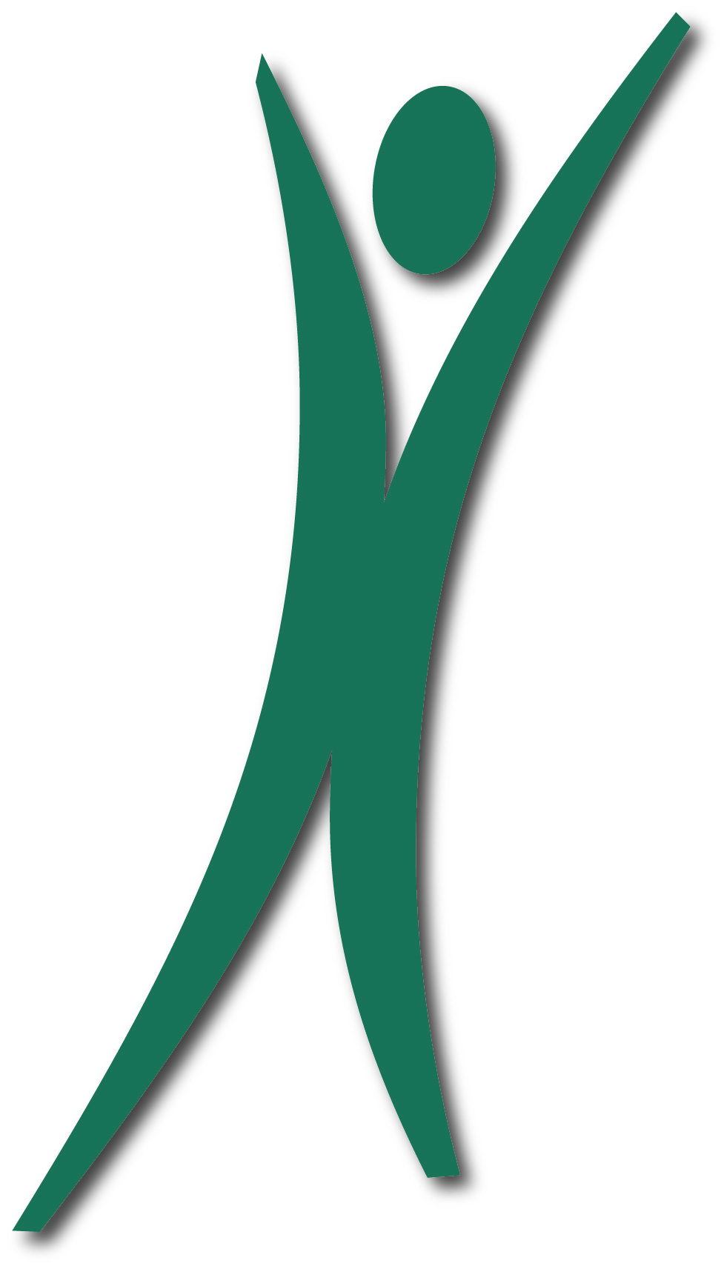


Erin Scott
2026

Table of Contents
Terms and Definitions 1
Device 1
Anatomical 1
Your Healthcare Team 1
Types of Amputations and Considerations 2
Upper Limb 2
Trans-Radial 2
Trans-humeral 2
Shoulder Disarticulation 2
Lower Limb 2
Symes 2
Transtibial 2
Transfemoral 2
Hip Disarticulation 2
Stages of Amputee Rehabilitation 3
Post-Operative Phase 3
Stump Protector 3
Pre-Prosthetic Phase 3
Gait Training 3
Prosthetic Prescription Phase 4
Residual Limb Management 5
Volume Control 5
Contracture Prevention 6
Wound Healing 6
Pain Management 6
Care of Sound Side Limb 6
Stump Protectors 7
Device and Liner Management 9
Limb Care 9
Skin Care 9
Prosthesis Care 10
Wearing your Prosthesis 10
Clothing Recommendations 12
Recommendations for lower extremity amputations 12
Recommendations for upper extremity amputations 12
Recommendations on what to wear for your appointments 12
Considerations At Home 13
Mental Health Considerations 14
Funding 15
Alberta 15
Alberta Aids to Daily Living (AADL) 15
Assured Income for the Severely Handicapped 15
Canada 15
Non-Insured Health Benefits (NIHB) 15
Veterans Affairs Canada 15
Canadian Armed Forces 15
Royal Canadian Mounted Police (RCMP) 15
Other 16
Workers Compensation Board (WCB) 16
The War Amps 16
Private Insurance 16
Amputee Specific Programs 17
Recreation 17
Alberta Amputee Sport and Recreation Association (AASRA) 17
Amputee Coalition of Canada 17
Canadian Adaptive Snowsports (CADS) 17
Canadian Amputee Golf Association 17
Canadian Paralympic Committee 17
Rocky Mountain Adaptive 17
The War Amps 17
William Watson Lodge 17
Transportation 17
Calgary Transit Access 17
Wheelchair Accessible Vehicle Calgary 18
SOURCES 19

Terms and Definitions
Below is a list of various terms you may hear after amputation

Device
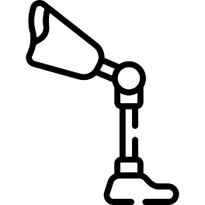
- Prosthesis: A device that replaces a missing limb
- Donning: Putting on your prosthesis
- Doffing: Taking off your prosthesis
- Shrinker socks: Compression socks which help to control edema post amputation
- Stump Protector: Rigid device dispensed after amputation. Used to protect Trans-Tibial amputations, as well as straightening the knee to prevent knee flexion contractures from developing during post-operative healing

Anatomical
- BKA: Below Knee Amputation
- AKA: Above Knee Amputation
- Edema: Swelling
- Phantom Limb Pain: Painful sensations coming from the limb that is no longer present. The limb is gone but the pain is real
- Phantom Limb Sensation: The amputated limb still feels present, though without pain
- Gait: The manner and style of walking

Your Healthcare Team
- Physiatrist: a medical doctor who specializes in physical medicine and rehabilitation
- Prosthetist: A healthcare professional who makes and fits prosthetic devices
- Social Worker: a trained healthcare professional who helps vulnerable people and communities
- Physical Therapist: trained professional who evaluates and treats abnormal physical function related to an injury, disability, or other health condition
- Occupational Therapist: allied health professional who helps promote an individual’s ability to fulfill their daily routines and roles

Types of Amputations and Considerations
The following is a list of common types of amputations and their criteria

Upper Limb

Trans-Radial
- May be referred to as Below Elbow (BE)
- The bones of the lower arm (radius and ulna) have been cut

Trans-humeral
- May be referred to as Above Elbow (AE)
- The upper arm bone (humerus) has been cut

Shoulder Disarticulation
- Surgical separation of the entire arm from the shoulder joint

Lower Limb

Symes
- An amputation at the level of the ankle where the heel pad is preserved

Transtibial
- May be referred to as Below Knee (BK)
- The bones of the lower leg (tibia and fibular) have been cut

Transfemoral
- May be referred to as Above Knee (AK)
- The upper leg bone (femur) has been cut

Hip Disarticulation
- Surgical separation of the entire leg from the hip joint

Stages of Amputee Rehabilitation
- One of the most common concerns patients have post operation is “how long until I can get back to my normal?”
- It’s important to understand that very few will follow a strict and objective timeline, and that progress is dependent on many factors including healing, strength, age, and self-determination
- Everyone progresses through rehabilitation at their own pace, and its important to not compare your own process with someone else’s
- Below is an idea of what to expect during each phase of your rehabilitation

Post-Operative Phase
- Initial focus of the post-operative phase is wound healing and pain control
- This phase also involves measures to help protect the limb and shape it for prosthetic use
  - This will involve a custom fabricated stump protector and use of shrinker socks
- Proper healing and limb shaping can typically take around 42+ days (cited from school notes)

Stump Protector
- See page (insert)
- This device is meant for transtibial amputations
- Helps to protect residuum, especially when ambulating with a wheelchair where limb is supported straight out
- Helps prevent knee flexion contractures from developing post operation as it holds limb straight

Pre-Prosthetic Phase
- After the incision site has healed, the patient will work with their physical therapist to increase muscle strength and range of motion.
- We will typically cast you for a prosthesis about 4-6 weeks post amputation
- This allows enough time for wound healing and volume control

Gait Training
- Prosthetic training begins with learning to don/doff the device, transition of sitting to standing, weight bearing in the device, caring for the residual limb, and developing standing balance

Prosthetic Prescription Phase
- Your prosthetic prescription phase will take place through the fitting of a few devices
- It is typical to start with the fitting of a clear check socket
  - This allows the clinician to ensure that your limb fits well within the socket, with no areas of concern
- The prosthetic prescription phase may seem long…. It is important to understand that your residual limb will significantly change in the first year after amputation
- Temporary devices
  - You will initially be fitted with a temporary prosthesis
  - This device will have a clear plastic socket, wrapped in fiberglass, set up on aluminum, stainless steel and/or titanium componentry
  - With this device you will begin you gait training, and start getting accustomed to the use and fit of a prosthesis
  - This device can also be modified as you further heal and strengthen post op
  - The first year after amputation your residual limb volume will shrink significantly
    - This is due to a combination of wound healing and muscular atrophy
  - Once volume change has stabilized you will then progress to a permanent prosthesis
  - Time spent with a temporary prosthesis is very dependent on the individual, their health and motivation
- Definitive device – 2-4 years
  - Once we have optimized fit and you have achieved independent ambulation, we will fabricate a definitive prosthesis
  - The definitive socket will be fabricated from a resin lamination incorporating fiberglass, carbon fiber, or other composite materials
  - Your new socket will still be set up on aluminum, stainless steel, or titanium componentry, but you may request a foam cosmetic cover, to give your prosthesis a more anatomical shape

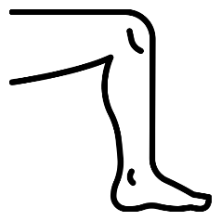

Residual Limb Management

Volume Control
- Compressive socks are applied as soon as postoperative drainage is removed
- Shrinker socks help to control edema, reduce pain, prevent contractures, and prepare the limb volume for adequate prosthetic fitting
- A recycled coffee can may be used as a donning aid to help ensure a uniform, graduated compression on the limb
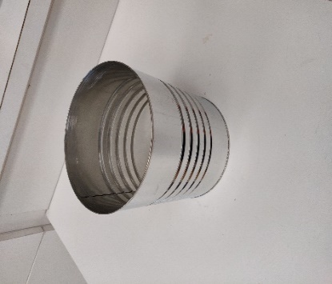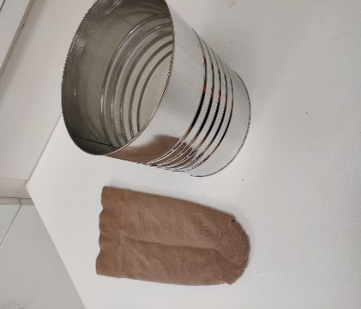
- With the sock facing right side out, place inside coffee can, and stretch the top to go around the coffee can bring
- Then with open palms, massage the sock down the exterior of the coffee can, until the end of the sock and stretched across the top of the can like so
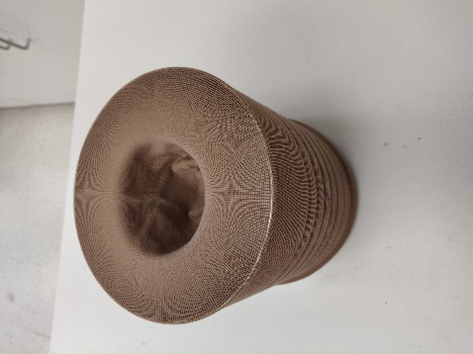
- Then push your residuum into the centre, pulling the can up around your limb until the shrinker sock has been fully donned
- IMPORTANT: Ensure there are no wrinkles or overlapping fabric once the sock is donned
- Wear your shrinker sock whenever you are not wearing your prosthesis to best control swelling, pain, and limb shape
- Hand wash sock every day with mild soap and water. Hang to dry only
- We will typically dispense two shrinker socks so one can be washed while the other in worn

Contracture Prevention
- Contractures are formed when muscles and tendons tighten and shorten resulting in painful and restricted movement
- Regular exercise, stretching, and frequent positioning changes can help prevent contractures from happening
- It is easier to prevent a contracture from forming than to stretch out a contracture once it has developed!
- For transtibial amputations, refrain from letting your leg hand down for long period of time while sitting. Support your leg in a straight position using the board on your wheelchair, or a footrest
- Do not lay with leg extended with a pillow or rolled up towel under the knee
- To prevent hip flexion contractions, alternate your sitting/laying position often and try to spend at least 3 periods of 20 minutes a day laying on your stomach

Wound Healing
- Patients are kept non weight bearing until the surgical site wounds are fully healed
- Suture site should be checked regularly

Pain Management

Care of Sound Side Limb
- Post amputation, your sound side limb will require continued care and attention as well, especially for persons diagnosed with diabetes
- Wear comfortable well-fitting and supportive shoes
- Keep nails trimmed
- Wear cotton socks with no elastic cuff
- Monitor the limb for any sores, redness and swelling, and alert your doctor right away

Limb Protectors

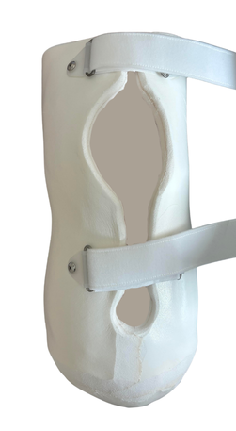
A Limb Protector, also known as a removable rigid dressing, is a custom-made device that is commonly used after a new below-knee amputation.
A protector helps to:
- Protect the sensitive end of your residual limb from getting bumped
- Reduce the risk of rupturing the suture in case of a fall
- Keeps the knee straight, preserving range of motion essential for walking
Features:
- Removable allowing for inspection and cleaning of the wound as well as changing dressings
- Soft interface provides comfort
- Rigid interior support provides protection from bumps and falls

How to put it on
- Put on the long thin sock that was provided to you by your prosthetist. This makes it more breathable and prevents excess perspiration
- Undo all the straps. Closing the Velcro on itself keeps it from getting tangled or catching on clothing
- Slide your residual limb in, making sure the curve of the plastic flap contours your knee once closed
- Attach all the Velcro straps. The straps should be snug, but not uncomfortably so.

When to wear it
- When you are in your wheelchair and have your leg up on the amp board. This will keep it from getting bumped.
- In bed, wear it as much as possible. It can be taken off occasionally to move your leg around, do some exercises, and to work on de-sensitizing the limb and mobilizing the scar.
- When you are sleeping. For the first while it is advisable to try and wear it to bed to avoid a fall from getting out of bed in the middle of the night

Device and Liner Management

Limb Care
- Take a bath or shower at night instead of in the morning. Your limb may swell in the hot water or when hanging as you sit or stand to bathe. This may make it difficult to put on your prosthesis
- Avoid sitting or sleeping with a towel or pillow under your knee. This may lead to a contracture (inability to straighten the knee), which will make it more difficult to walk.
- Wear your shrinker sock when you aren’t wearing your prosthesis. This will help reduce swelling

Skin Care
- Carefully inspect your residual limb before and after wearing your prosthesis. Use a mirror to see the end of your limb. Red pressure areas may lead to skin breakdown. If the redness does not disappear within 15-20 minutes, contact your prosthetist. You may need an adjustment to your socket.
- Wash your limb daily using mild soap and water. Pat dry.
- If you are having problems with the fit of your socket that is causing discomfort and/or skin breakdown, contact your prosthetist immediately.
- If you have skin breakdown, have it cared from properly by a professional. You may have to take time off from wearing your prosthesis while your limb heals.

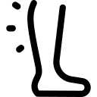

Prosthesis Care
- Wash your liner every day. Turn the liner inside out and wash it with mild soap and water. Rinse thoroughly. Turn right-side out and air dry. The liner can also be machine washed (40°/HOT) with mild detergent. Rinse thoroughly. Turn right-side out and air dry. Do not use bleach, fabric softeners or other products.
- Wear clean prosthetic socks. Machine wash in warm water, gentle cycle. Use mild detergent, no bleach, and no liquid softener. Tumble dry
- Clean your socket as needed. Wipe clean with a soft cloth and mild soap and water. Air dry
- Suspension sleeve: Clean the inside of the sleeve using mild soap and water. Turn right-side out and air dry

Wearing your Prosthesis

- Inspect your residual limb for any redness or skin breakdown.
- Turn your gel liner inside-out. Use the palms of your hands to roll on the liner and avoid puncturing the gel with your fingernails. Check that no air pockets are present.
- Socks – Use socks as needed to maintain a proper fit. Amount of sock ply may change dramatically in the first few months as your limb shrinks. Make sure there are no wrinkles in your socks before putting on the socket.
NOTE: Socks come in different thickness, or “ply” (1 ply, 3ply= yellow, 5ply=green). You may need a combination of socks to achieve the right ply.
- Step into the socket of your prosthesis. When on properly, your kneecap should be cupped in the U-shape on the front.
- Roll up the suspension sleeve using the palms of your hands. Check for and remove any wrinkles in the sleeve. Make sure there are at least two inches of gel in contact with your skin. This is important to create a seal for suspension.
- Stand up with support. You may hear air escaping from the valve. Carefully lift your leg to check suspension before walking.
- After 15-20 minutes of wear, remove your prosthesis and inspect your limb. Notify your prosthetist or any skin breakdown or redness that doesn’t go away within about 20 minutes.

Clothing Recommendations

Recommendations for lower extremity amputations

- Wear shoes that are the same heel height, and under 1” tall
- Wide leg pants are recommended for easy fit over prosthesis
- Pants can also be altered to include an “invisible zipper” to allow for easy donning and doffing of device

Recommendations for upper extremity amputations

- Loose clothing with elastic waistbands such as sweatpants, yoga pants, t-shirts, hoodies, etc.
- Shoes with Velcro or slip-on shoes

Recommendations on what to wear for your appointments

- During your casting appointments, we will wrap the residual limb with wet, plaster bandage to create the model we need for socket fabrication
- Plaster is messy!
- Please wear short sleeve or short legged clothing that you do not mind getting dirty!
- In clinic we also have casting shorts available in case you forget or unable to bring the proper shorts

Considerations At Home

- Modifications may need to be made around the home to help adjust more easily
- Railings should be installed in stairways if they are not currently present
- It is often helpful to have a pair of “inside shoes”, as alignment of the device is set to a shoe heel height
- Indoor shoes will also help with grip to prevent slipping in the home
- Do not walk on wet or slick floors
- Consider railing in the bathroom and shower, as well as a shower stool

Mental Health Considerations

- Whether it’s the result of disease or trauma, amputation surgery, loss of limb requires physical, psychological, and social adjustments and support
- Actionable tools empower individuals to take an active role in their emotional well being
  - Set incremental goals
    - Focus on short term, functional milestones (increasing daily wear time) rather than single, long-term outcomes
  - Build a support network
    - Connecting with peer support groups provides first hand insights and breaks isolation
  - Professional guidance
    - Consulting with mental health professionals such as psychologists, clinical social workers or counselors

Funding

Alberta

Alberta Aids to Daily Living (AADL)
- AADL helps Albertans with a long-term disability, chronic or terminal illness to pay for basic medical equipment and supplies

Assured Income for the Severely Handicapped
- Financial and health benefits for eligible Albertans with a permanent medical condition that prevents them from earning a living.

Canada

Non-Insured Health Benefits (NIHB)
- The Non-Insured Health Benefits (NIHB) program provides eligible First Nations and Inuit clients with coverage for a range of health benefits that are not covered through other:
  - Social programs
  - Private insurance plans
  - Provincial or territorial health insurance

Veterans Affairs Canada
- Provides coverage for prostheses, orthoses, and other related accessories. Necessary repairs and maintenance are also covered.

Canadian Armed Forces

Royal Canadian Mounted Police (RCMP)

Other

Workers Compensation Board (WCB)
- In Alberta, the WCB provides compensation (including wage-replacement benefits and medical aid) to workers who suffer work-related injuries during the course of employment. WCB is funded by premiums paid by employers in compulsory industries in Alberta

The War Amps
- Adult Amputee Program
  - The War Amps provides amputees with financial assistance for artificial limbs and information resources that address all aspects of amputation
  - The Adult Amputee Program, which provides financial assistance towards the cost of artificial limbs, is available to amputees 18 and older residing in Canada
- Child Amputee Program
  - The Child Amputee (CHAMP) Program offers comprehensive services to child amputees and their families, including financial assistance, regional seminars, and peer support
  - CHAMP serves children in Canada (under 18) who are born missing a limb or have lost a limb due to an accident or medical causes. Children who are missing multiple limbs may also qualify for enrolment in JUMPSTART

Private Insurance
  - Many insurance companies have some coverage for prosthetics, but this varies depending on the policy.

Amputee Specific Programs

Recreation

Alberta Amputee Sport and Recreation Association (AASRA)

Amputee Coalition of Canada

Canadian Adaptive Snowsports (CADS)

Canadian Amputee Golf Association

Canadian Paralympic Committee

Rocky Mountain Adaptive

The War Amps
War Amps resources: https://www.waramps.ca/ways-we-help/living-with-amputation/#Pain

William Watson Lodge
William Watson Lodge provides year-round, barrier-free, wilderness lodging for persons with disabilities, seniors and their families. It is situated in beautiful Peter Lougheed Provincial Park, on Lower Kananaskis Lake. The goal of this facility is to connect people of all abilities, all ages and all cultures to recreational opportunities in nature through providing needs-based accommodation and inspiring more accessible experiences.

Transportation

Calgary Transit Access
Book direct trips
Requires application, apply at https://www.calgarytransit.com/content/transit/en/home/calgary-transit-access/apply-for-service.html

Wheelchair Accessible Vehicle Calgary
Book your taxi trip using the smart phone app, website, or phone. To book by phone, you call Wheelchair Accessible Vehicle Calgary (403-974-1110​) and the closest available taxi will be dispatched to anywhere in Calgary and give you the approximate wait time. There is no pre-registration required for this on-demand service. At this time, you cannot book a rideshare vehicle using this service.

